**Lab: Create Azure IoT Hub and Devices**

**Introduction**

During this lab, you will learn how to setup Sensors, devices in iot hub

**Estimated Time**

30 minutes

**Objectives**

At the end of this lab, you will be able to:

* Create IoT Hub
* Create IoT Device in you IoT Hub

**Pre-requisites**

1. Internet Access
2. Active Azure Subscription.

Table of Contents

Lab: Sensors, Devices and Simulators 3

Exercise 1: Setup Azure for IOT 3

Exercise 2: Create a Device in IOT Hub 12

Lab: Sensors, Devices and Simulators

Exercise 1: Setup Azure for IOT

This exercise shows how to create an IOT Hub in Azure

Tasks

1. Login to Azure Portal

Login to Azure portal [**http://portal.azure.cn**](http://portal.azure.cn)using valid credentials which has subscription to create Azure Services

1.1 Type in a valid user name.

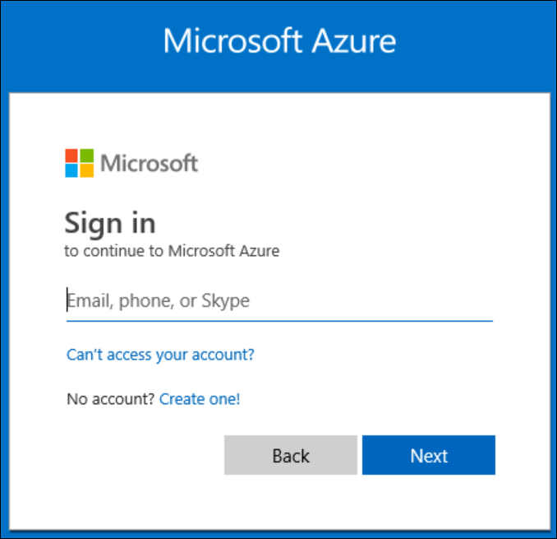

If you entered an Corporate account, 2 factor authenticated will be required…following tasks 1.2 - 1.4

If you entered a windows live account… go to task 1.5

1.2 Select **Sign in** with a username and password instead

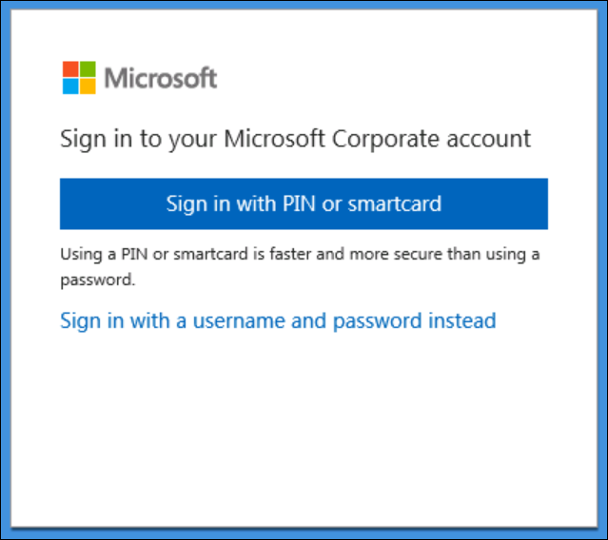

1.3 Type in your password and click on **Sign in**

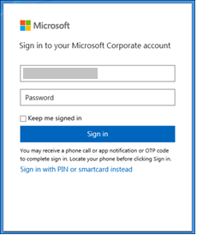

1.4 Click on **Sign in** with your phone or token device

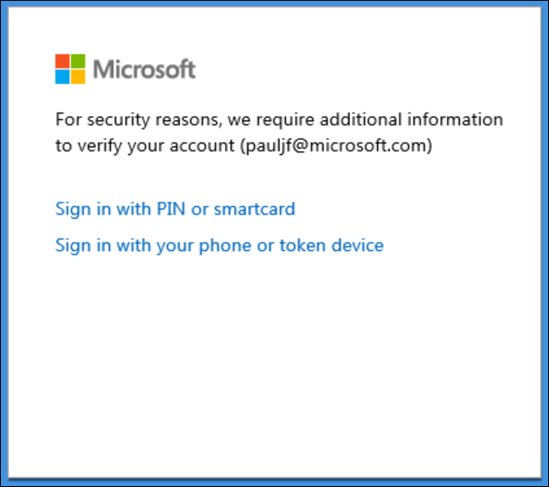

This completes the login process for Corporate accounts, go to exercise 2

1.5 Enter you password can click on **Sign in**

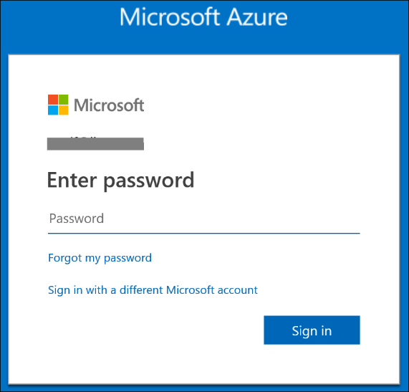

You are logged into Azure and ready to continue with the next task.

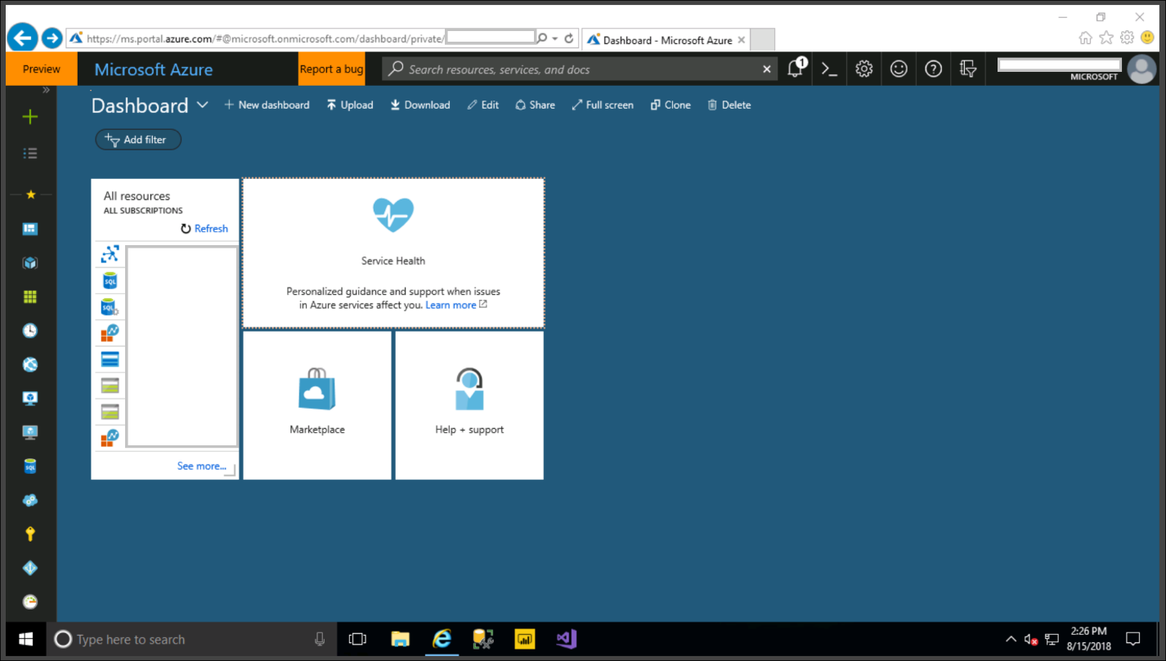

1. Create a new Resource Group

Create a new resource group to collect and manage all your application resources for this lab

Click on **Resource groups** in the left panel

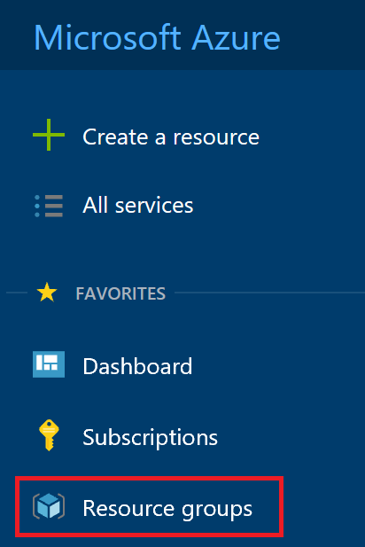

Click on **+ Add** button

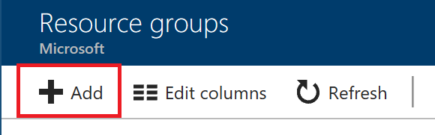

Enter the **Resource Group** name, choose **subscription** and then **Location**

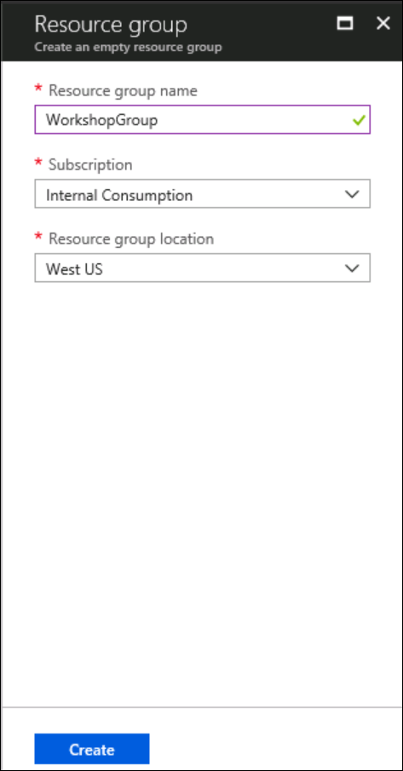

1. Create IOT Hub

Create an **IOT Hub** to connect your real device or simulator to this IOT Hub and start sending data.

Click on **+ Add** button

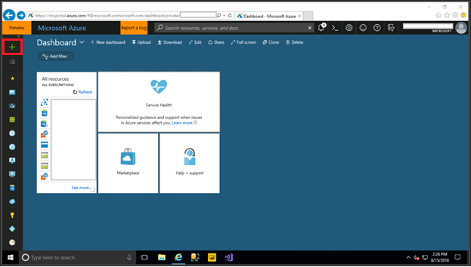

Click on **Internet of things**

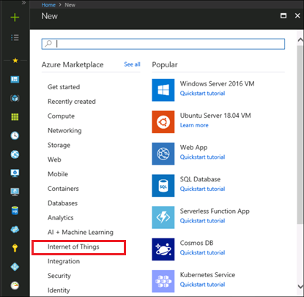

Click on IoT Hub

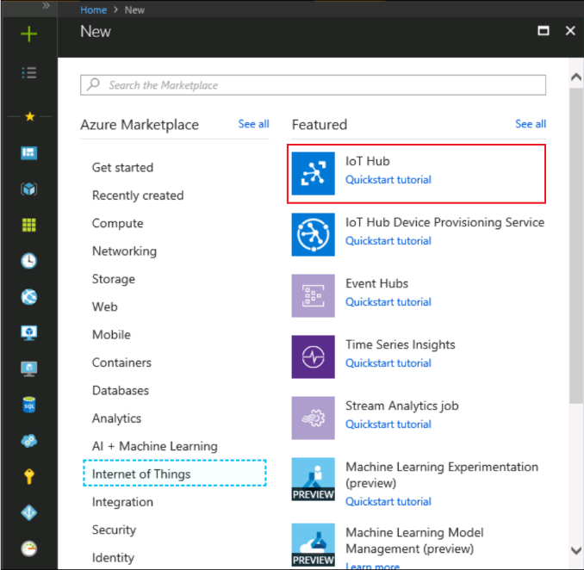

Make sure you select **the resource group** you created in previous step.

In the Name field, **enter a unique name** for your IoT hub. The name of your IoT hub must be **unique** across all IoT hubs.

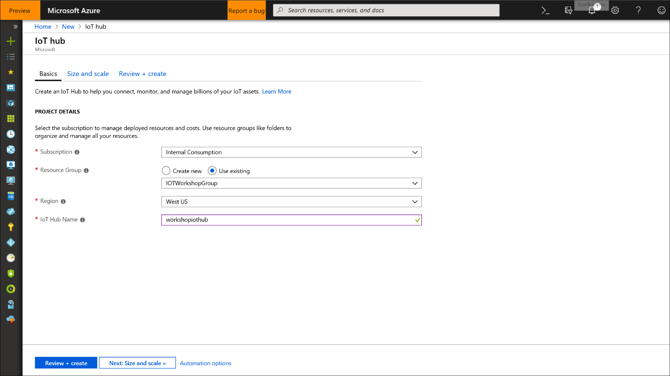

Click **Size and Scale** button.

In the Tier filed, select **S1 tier**.

You can choose from several tiers depending on how many features you want and how many messages you send through your solution per day.

The **S1 tier** allows total of **400,000 messages** **per unit per day**.

For details about the other tier options, see Choosing the right IoT Hub tier. <https://azure.microsoft.com/en-us/pricing/details/iot-hub/>

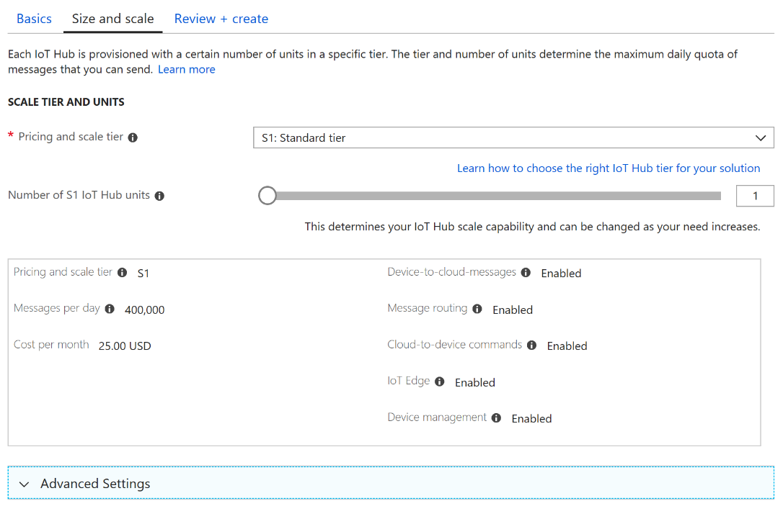

Click **Review and Create Button** to create the IoT Hub.

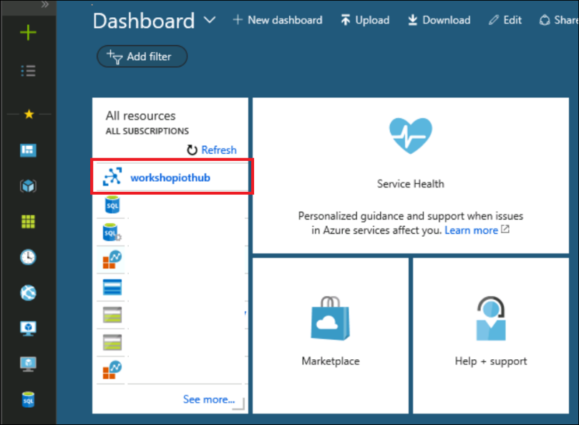

Exercise 1 has been completed

Exercise 2: Create a Device in IOT Hub

This exercise shows how to use the Raspberry PI Simulator to send Data to IoT Hub

Tasks

1. Create a Device in IoT Hub

On the Azure Portal, click on the IoT Hub created in the previous exercise

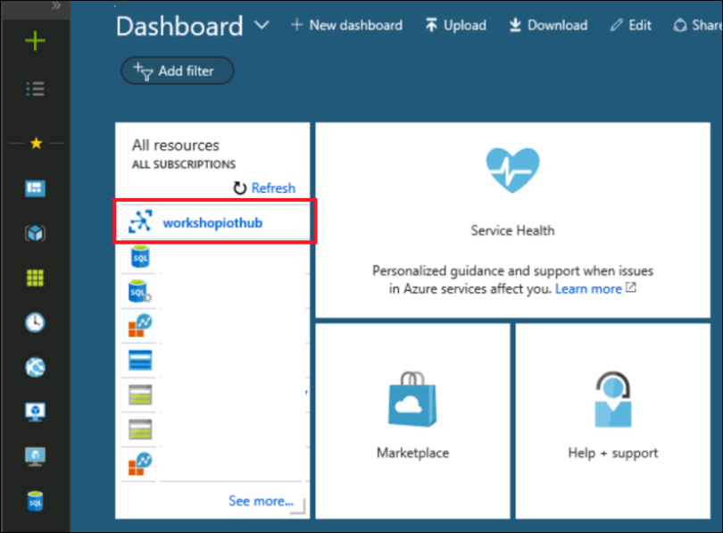

Scroll down and click on **IoT devices.**

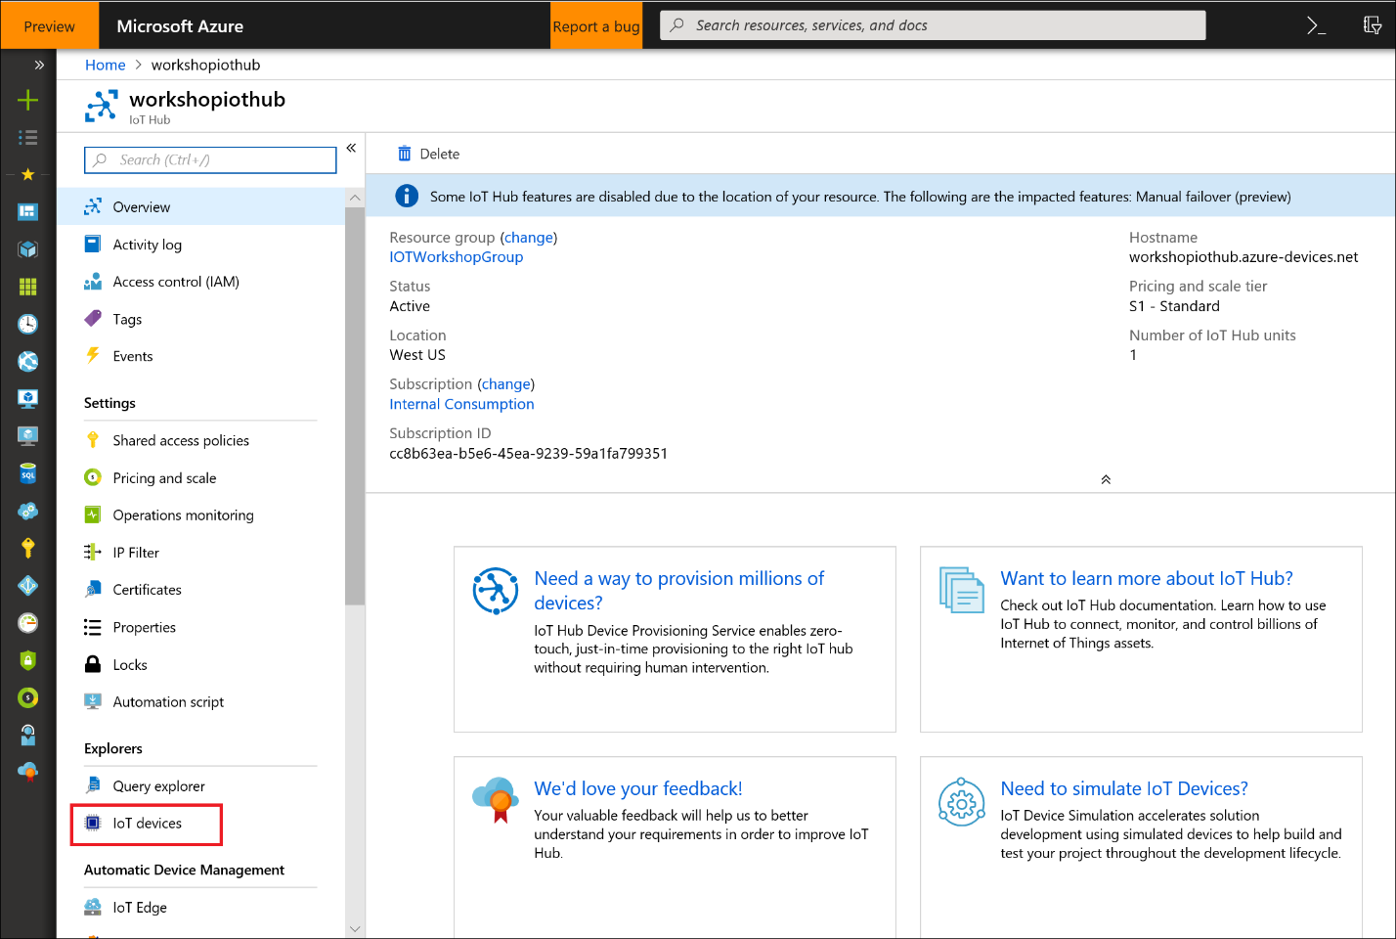

Click on **+ Add** and enter a **Device ID** and Click **Save**

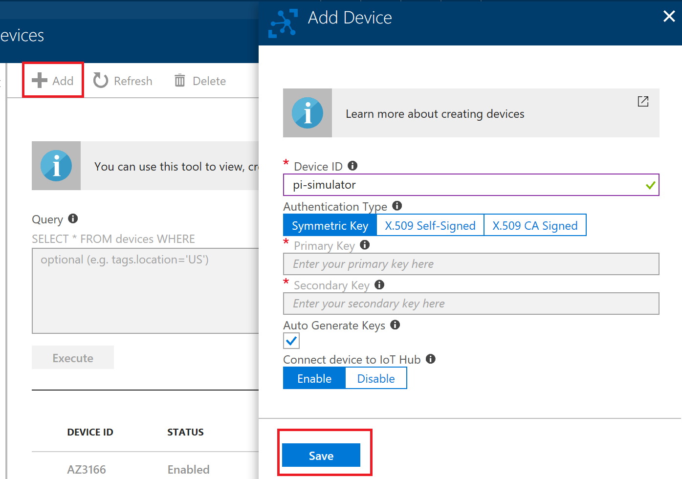

Click on the **Device** and copy the **Primary Key Connection String,** you will use this connection string to connect the device to iot hub in later excrcise.

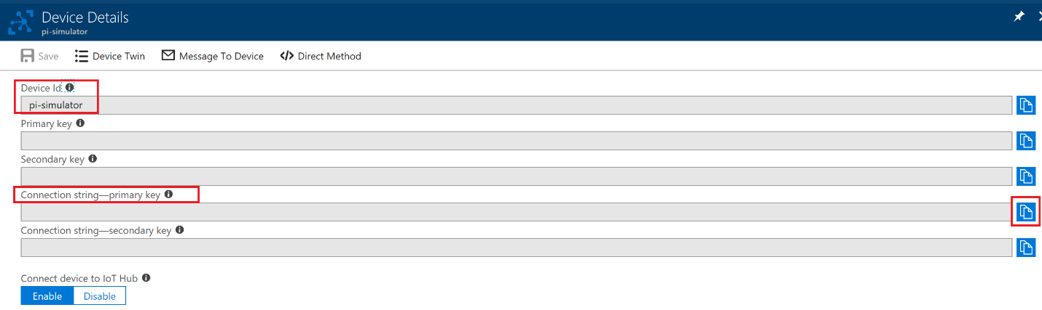

*Exercise 2 has been completed*